**Laboratorul 1 WEB N=7**

***1.Structura generală a unui document HTML***

**1.** **Ce va afişa documentul .html cu următorul conţinut:**

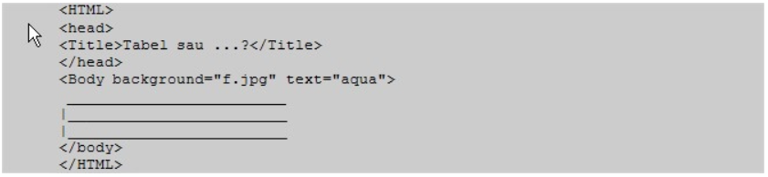

**Conținul acestui document l-am introdus în Notepad++ și am obținut:**

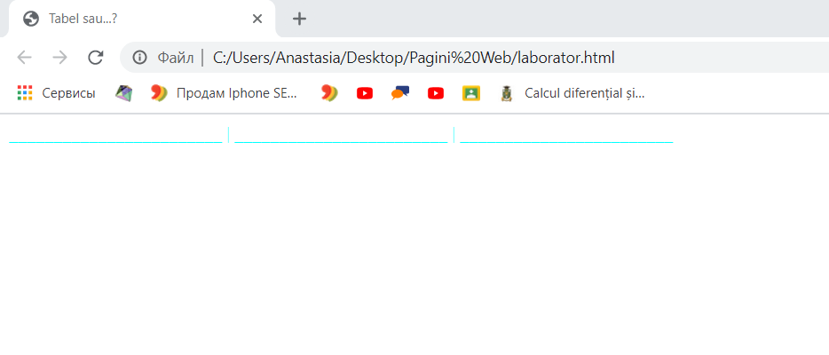

**Observăm că am obținut o pagină cu numele „Tabel sau…?” conținutul documentului care a fost introdus intre “<Body></Body>” îl putem vedea în acest document, însă nu este în acea ordine pe care am introdus-o. Textul este de culoare aqua, cum am și specificat-o in document. Imaginea “f.jpg” care ar fi trebuit să fie utilizată ca fundal al documentului, însă aceasta nu a avut loc din cauza ca imaginea aceasta nu e intrun fisier cu documentul html. Daca vroiam textul sa il arate asa cum lam introdus foloseam tag-urile <pre></pre>**

***2.Formatarea textului***

**Varianta 2.**

**A) Creaţi o pagină web cu fundalul de culoare blue, textul de culoare white, conţinutului paginii fiind afişat la distanţa de 40 pixeli de marginea stîngă şi 20 pixeli de marginea de sus aleferestrei browser-ului. Aliniaţi la centru titlul unei instituţii de învăţămînt, nivelul titlului fiind egalcu 2. Despărţiţi-l de restul conţinutului printr-o linie orizontală roşie cu grosimea 3 şi lungimea 50%din fereastra browser-ului.**

***<Html>***

***<Head>***

***<Title> Lucrare de laborator. Varianta 2</Title>***

***<H2 align="center"> I.P.L.T "Olimp" </H2>***

***</Head>***

***<Body leftmargin="40" topmargin="20" bgcolor="blue" text="white">***

***<HR size="3" width="50%" color="red">***

***</Body>***

***</Html>***

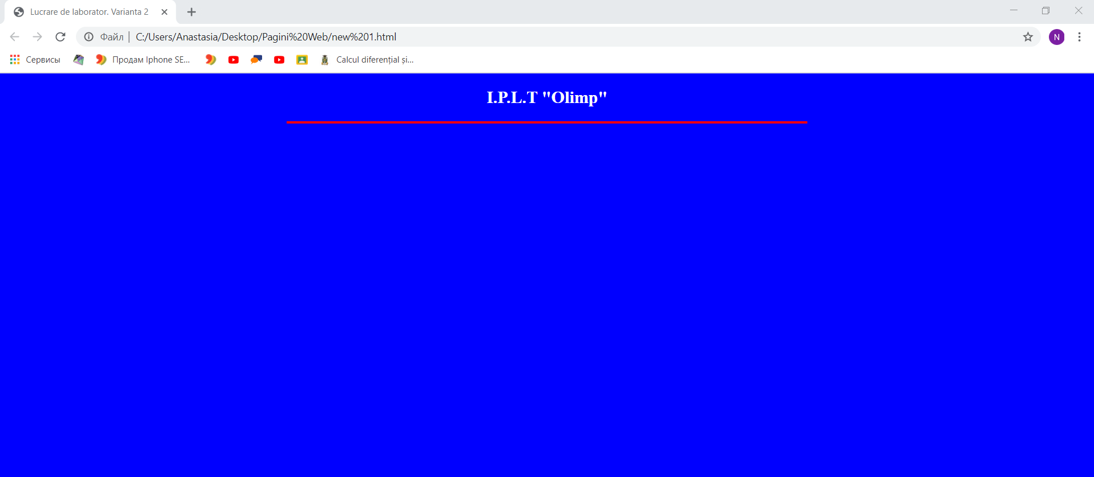

**B) Creaţi o pagină web care va afişa în centrul paginii formula | a + b| < |a| + |b|, pentru orice numerenenule a şi b.**

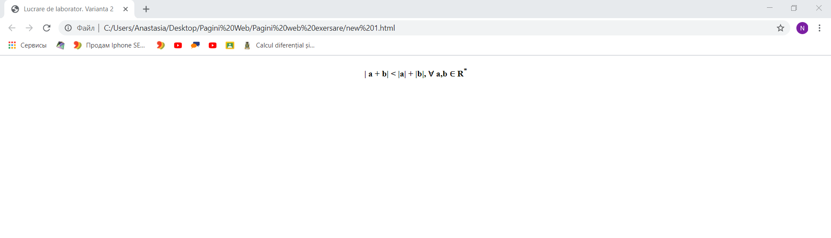

**<Html>**

**<Head>**

**<Title> Lucrare de laborator. Varianta 2</Title>**

**</Head>**

**<Body align="center" topmargin="20" >**

**<b>| a + b| < |a| + |b|, &#8704; a,b &#8712; R<sup>*</sup></b>**

**</Body>**

**</Html>**

**C) Creaţi o un document html care va afişa următoarea pagină web:**

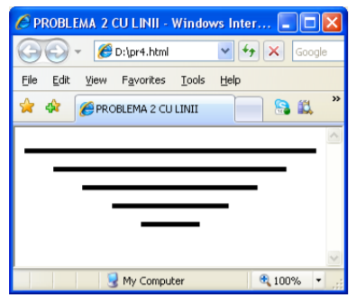

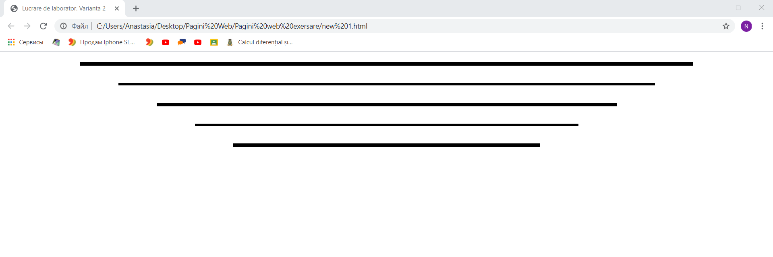

**<Html>**

**<Head>**

**<Title> Lucrare de laborator. Varianta 2</Title>**

**</Head>**

**<Body align="center" topmargin="20" >**

**<hr size="7" width="80%" color="black"><br>**

**<hr size="5" width="70%" color="black"><br>**

**<hr size="7" width="60%" color="black"><br>**

**<hr size="5" width="50%" color="black"><br>**

**<hr size="7" width="40%" color="black">**

**</Body>**

**</Html>**

**Laboratorul 2 WEB N=7**

**Exercitiul cu Liceele:** [**https://drive.google.com/file/d/1wn2kfnUVh_lfNGwK9rFrvsdb2Ac9rstL/view?usp=sharing**](https://drive.google.com/file/d/1wn2kfnUVh_lfNGwK9rFrvsdb2Ac9rstL/view?usp=sharing)

***1. Crearea listelor (VariantaVIII)***

**1. Creaţi o un document html care va afişa următoarea pagină web:**

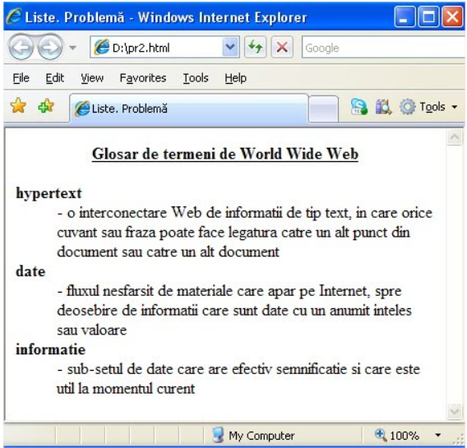

**<Html>**

**<Head>**

**<Title> Liste.Problemă</Title>**

**<H4 align="center"> <u> Glosar de termeni de World Wide Web </u></H4>**

**</Head>**

**<Body >**

**<H4>hypertext </H4>**

**<pre> - o interconectare Web de informatii de tip text, in care orice <br>**

**cuvant sau fraza poate face legatura catre un alt punct din<br>**

**document sau catre un alt document</pre>**

**<H4>date</H4>**

**<pre> - fluxul nesfarsit de materiale care apar pe Internet,spre<br>**

**deosebire de informatii care sunt date cu un anumit inteles<br>**

**sau valoare</pre>**

**<H4> informatie</H4>**

**<pre> - sub-setul de date care are efectiv si care este<br>**

**util la momentul curent</pre>**

**</Body>**

**</Html>**

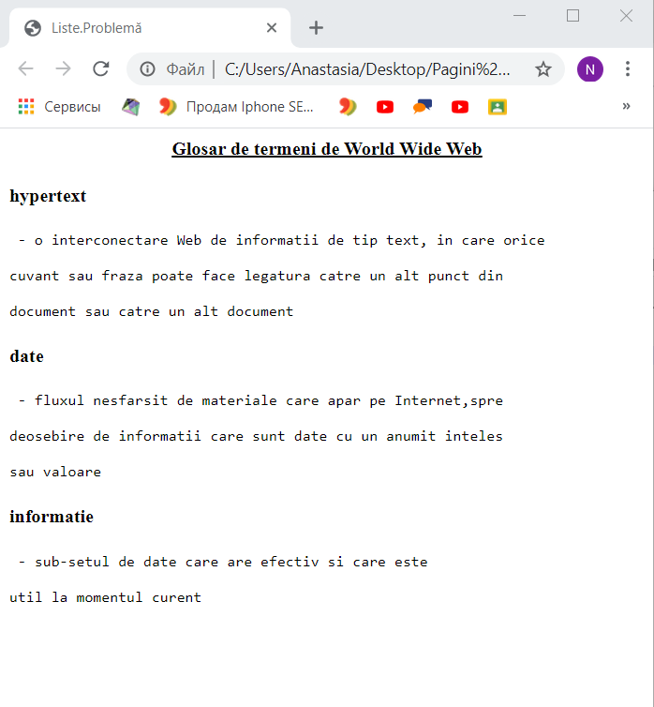

**Laboratorul 3 WEB N=7**

**1. Imagini**

**Creaţi o pagină web care va afişa următoarea pagină web.**

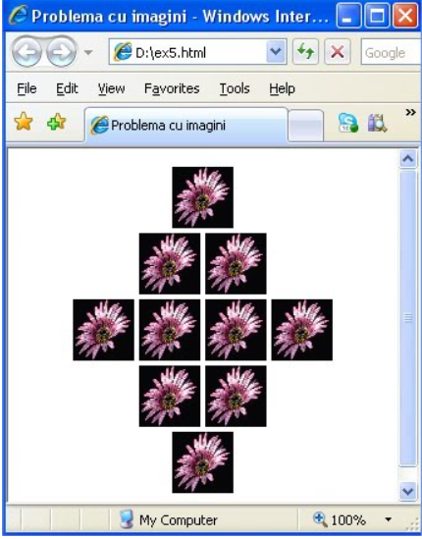

<!DOCTYPE html>

<html>

<head >

<title>Laborator nr.3</title>

</head >

<body align="center">

<img src="1.jpg" height="100" weight="100">

<br>

<img src="1.jpg" height="100" weight="100">

<img src="1.jpg" height="100" weight="100">

<br>

<img src="1.jpg" height="100" weight="100">

<img src="1.jpg" height="100" weight="100">

<img src="1.jpg" height="100" weight="100">

<img src="1.jpg" height="100" weight="100">

<br>

<img src="1.jpg" height="100" weight="100">

<img src="1.jpg" height="100" weight="100">

<br>

<img src="1.jpg" height="100" weight="100">

<br>

</body>

<html>

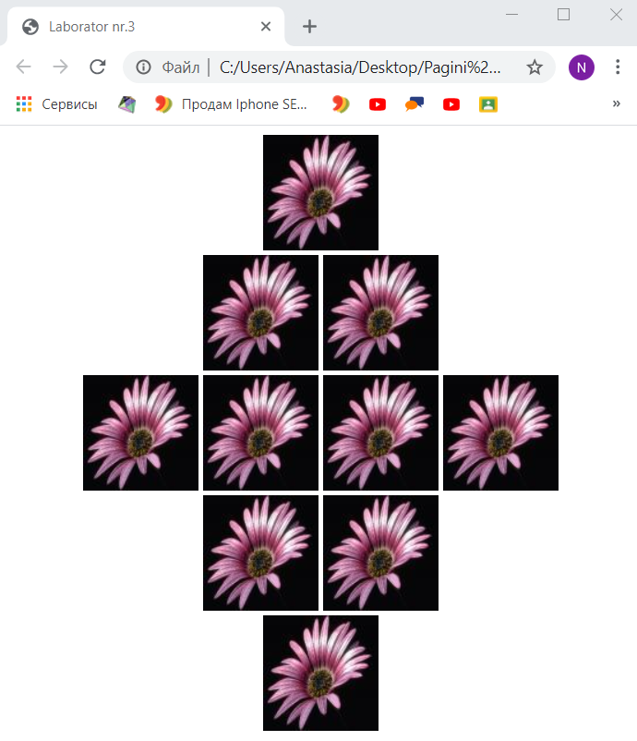

**2.Tabele**

**Creaţi o pagină web care va afişa următorul tabel:**

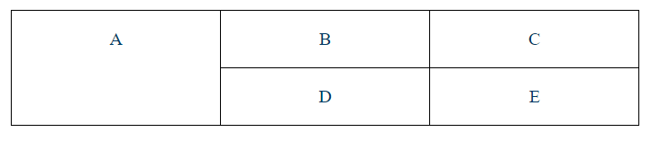

<!DOCTYPE html>

<html>

<table border=1 width="500" height="100" align="center" >

<tr>

<th rowspan="2">A</th>

<th>B</th>

<th>C</th>

</tr>

<tr>

<th>D</th>

<th>E</th>

</tr>

<

</table>

</html>

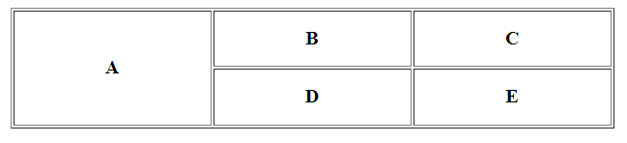

**Laboratorul 4 WEB N=7**

Creaţi o pagină web formată din două cadre de tip coloană cu chenar de culoare roşie şi lăţimea de 160 pixeli. Primul cadru va afişa o listă de denumiri de figuri geometrice, iar al doilea– desenele corespunzător acestor figuri. Indicaţie. Utilizaţi redactorul grafic Paint.

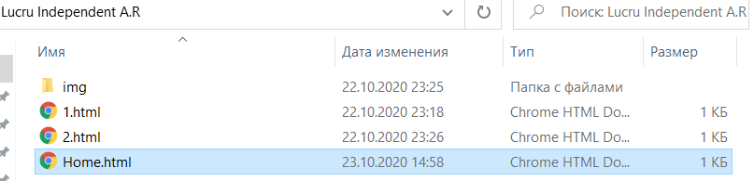

**<!DOCTYPE html>**

**<html>**

**<head >**

**<title>Lucru individual</title>**

**</head >**

**<frameset cols = "160,*" bordercolor = "red" >**

**<frame src = "1.html" scrolling="yes" noresize>**

**<frame src = "2.html" scrolling="yes" noresize>**

**</frameset>**

**<html>**

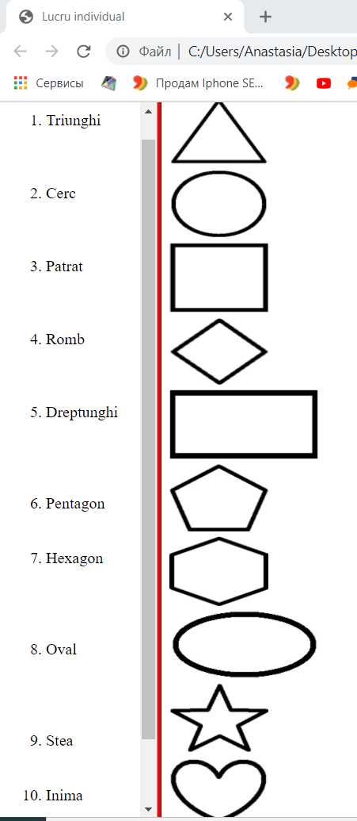

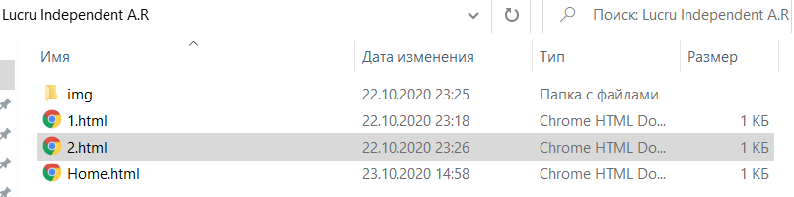

**<!DOCTYPE html>**

**<html>**

**<head >**

**<title>1.html</title>**

**</head >**

**<img src="img/t.png" height=70px width=100px><br>**

**<img src="img/c.png" height=70px width=100px><br>**

**<img src="img/p.png" height=70px width=100px><br>**

**<img src="img/r.png" height=70px width=100px><br>**

**<img src="img/d.png" height=70px width=150px><br>**

**<img src="img/pe.png" height=70px width=100px><br>**

**<img src="img/h.png" height=70px width=100px><br>**

**<img src="img/o.png" height=70px width=150px><br>**

**<img src="img/s.png" height=70px width=100px><br>**

**<img src="img/i.png" height=70px width=100px><br>**

**<html>**



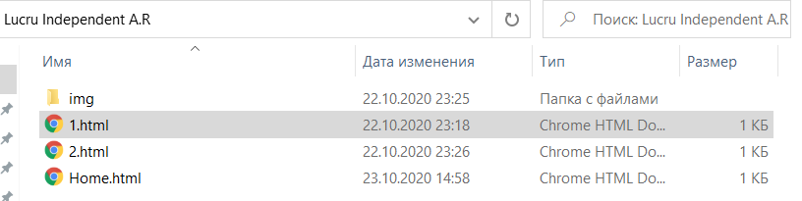

**<!DOCTYPE html>**

**<html>**

**<head >**

**<title>1.html</title>**

**</head >**

**<ol type="1"><br>**

**<li>Triunghi<br><br><br><br>**

**<li>Cerc<br><br><br><br>**

**<li>Patrat<br><br><br><br>**

**<li>Romb<br><br><br><br>**

**<li>Dreptunghi<br><br><br><br><br>**

**<li>Pentagon<br><br><br>**

**<li>Hexagon<br><br><br><br><br>**

**<li>Oval<br><br><br><br><br>**

**<li>Stea<br><br><br>**

**<li>Inima<br><br><br><br><br>**

**</ol>**

**<html>**

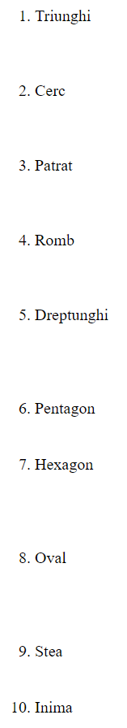

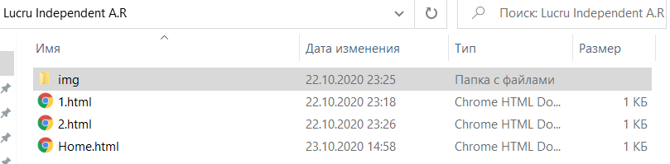

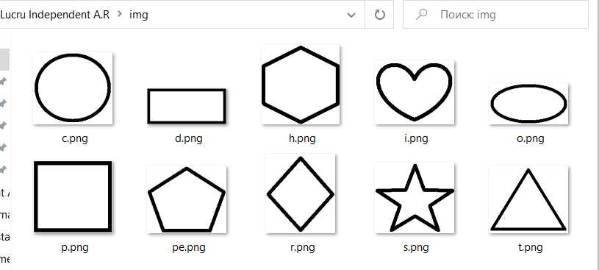

**Laboratorul 5 WEB N=7**

Creaţi o pagină web, care va afişa următoarea imagine. Fiecare din cele trei „săltare” din imagine va fi o legătură către un fişier html care va conţine informaţii despre ziarele, sau revistele, sau canalele TV din tară.

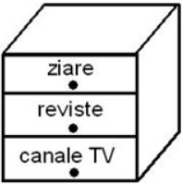

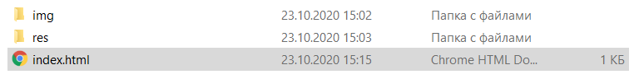

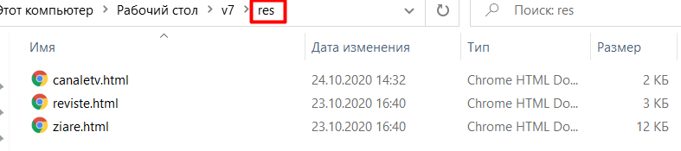

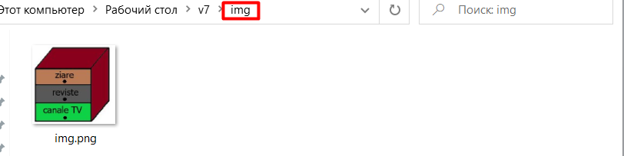

„Index.html” conține codul:

<!DOCTYPE html>

<html>

<head >

<title>Lucru independent</title>

</head ><body align=center>

<img src="img/img.png" usemap="#s">

<Map name="s">

<Area shape = rect coords="8,48,121,81" href="res/ziare.html" target="_blank">

<Area shape = rect coords="8,83,122,119" href="res/reviste.html" target="_blank">

<Area shape = rect coords="8,121,120,157" href="res/canaletv.html" target="_blank">

</Map>

</body>

<html>

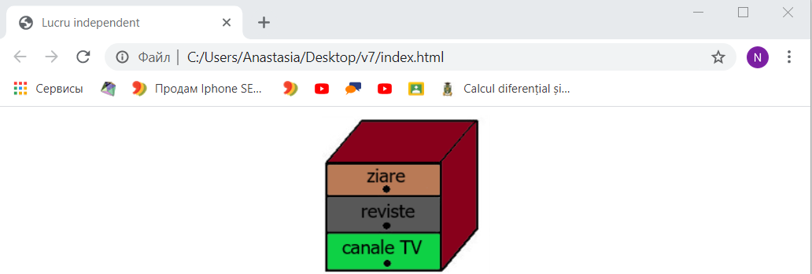

**Accesând saltarul “Ziare” vedem următoarea pagină:**

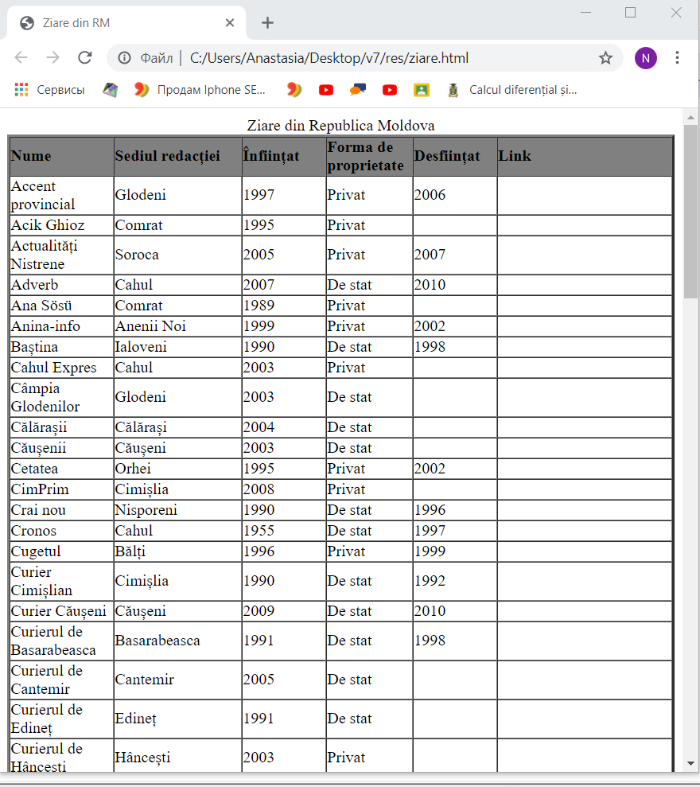

**Codul acestei pagini este:**

**<!DOCTYPE html>**

**<html>**

**<head >**

**<title>Ziare din RM</title>**

**</head >**

**<body>**

**<table border="3" cellpadding="0" cellspacing="0" >**

**<caption >Ziare din Republica Moldova**

**</caption>**

**<thead bgcolor="gray"><tr>**

**<th width="75" align="left">Nume**

**</th>**

**<th width="115" align="left">Sediul redacției**

**</th>**

**<th width="75" align="left">Înființat**

**</th>**

**<th width="60" align="left">Forma de proprietate**

**</th>**

**<th width="75" align="left">Desființat**

**</th>**

**<th width="75" align="left">Link**

**</th></tr></thead><tbody>**

**<tr>**

**<td>Accent provincial**

**</td>**

**<td>Glodeni**

**</td>**

**<td>1997**

**</td>**

**<td>Privat**

**</td>**

**<td>2006**

**</td>**

**<td>**

**</td></tr>**

**<tr>**

**<td>Acik Ghioz**

**</td>**

**<td>Comrat**

**</td>**

**<td>1995**

**</td>**

**<td>Privat**

**</td>**

**<td>**

**</td>**

**<td>**

**</td></tr>**

**<tr>**

**<td>Actualități Nistrene**

**</td>**

**<td>Soroca**

**</td>**

**<td>2005**

**</td>**

**<td>Privat**

**</td>**

**<td>2007**

**</td>**

**<td>**

**</td></tr>**

**<tr>**

**<td>Adverb**

**</td>**

**<td>Cahul**

**</td>**

**<td>2007**

**</td>**

**<td>De stat**

**</td>**

**<td>2010**

**</td>**

**<td>**

**</td></tr>**

**<tr>**

**<td>Ana Sösü**

**</td>**

**<td>Comrat**

**</td>**

**<td>1989**

**</td>**

**<td>Privat**

**</td>**

**<td>**

**</td>**

**<td>**

**</td></tr>**

**<tr>**

**<td>Anina-info**

**</td>**

**<td>Anenii Noi**

**</td>**

**<td>1999**

**</td>**

**<td>Privat**

**</td>**

**<td>2002**

**</td>**

**<td>**

**</td></tr>**

**<tr>**

**<td>Baștina**

**</td>**

**<td>Ialoveni**

**</td>**

**<td>1990**

**</td>**

**<td>De stat**

**</td>**

**<td>1998**

**</td>**

**<td>**

**</td></tr>**

**<tr>**

**<td>Cahul Expres**

**</td>**

**<td>Cahul**

**</td>**

**<td>2003**

**</td>**

**<td>Privat**

**</td>**

**<td>**

**</td>**

**<td>**

**</td></tr>**

**<tr>**

**<td>Câmpia Glodenilor**

**</td>**

**<td>Glodeni**

**</td>**

**<td>2003**

**</td>**

**<td>De stat**

**</td>**

**<td>**

**</td>**

**<td>**

**</td></tr>**

**<tr>**

**<td>Călărașii**

**</td>**

**<td>Călărași**

**</td>**

**<td>2004**

**</td>**

**<td>De stat**

**</td>**

**<td>**

**</td>**

**<td>**

**</td></tr>**

**<tr>**

**<td>Căușenii**

**</td>**

**<td>Căușeni**

**</td>**

**<td>2003**

**</td>**

**<td>De stat**

**</td>**

**<td>**

**</td>**

**<td>**

**</td></tr>**

**<tr>**

**<td>Cetatea**

**</td>**

**<td>Orhei**

**</td>**

**<td>1995**

**</td>**

**<td>Privat**

**</td>**

**<td>2002**

**</td>**

**<td>**

**</td></tr>**

**<tr>**

**<td>CimPrim**

**</td>**

**<td>Cimișlia**

**</td>**

**<td>2008**

**</td>**

**<td>Privat**

**</td>**

**<td>**

**</td>**

**<td>**

**</td></tr>**

**<tr>**

**<td>Crai nou**

**</td>**

**<td>Nisporeni**

**</td>**

**<td>1990**

**</td>**

**<td>De stat**

**</td>**

**<td>1996**

**</td>**

**<td>**

**</td></tr>**

**<tr>**

**<td>Cronos**

**</td>**

**<td>Cahul**

**</td>**

**<td>1955**

**</td>**

**<td>De stat**

**</td>**

**<td>1997**

**</td>**

**<td>**

**</td></tr>**

**<tr>**

**<td>Cugetul**

**</td>**

**<td>Bălți**

**</td>**

**<td>1996**

**</td>**

**<td>Privat**

**</td>**

**<td>1999**

**</td>**

**<td>**

**</td></tr>**

**<tr>**

**<td>Curier Cimișlian**

**</td>**

**<td>Cimișlia**

**</td>**

**<td>1990**

**</td>**

**<td>De stat**

**</td>**

**<td>1992**

**</td>**

**<td>**

**</td></tr>**

**<tr>**

**<td>Curier Căușeni**

**</td>**

**<td>Căușeni**

**</td>**

**<td>2009**

**</td>**

**<td>De stat**

**</td>**

**<td>2010**

**</td>**

**<td>**

**</td></tr>**

**<tr>**

**<td>Curierul de Basarabeasca**

**</td>**

**<td>Basarabeasca**

**</td>**

**<td>1991**

**</td>**

**<td>De stat**

**</td>**

**<td>1998**

**</td>**

**<td>**

**</td></tr>**

**<tr>**

**<td>Curierul de Cantemir**

**</td>**

**<td>Cantemir**

**</td>**

**<td>2005**

**</td>**

**<td>De stat**

**</td>**

**<td>**

**</td>**

**<td>**

**</td></tr>**

**<tr>**

**<td>Curierul de Edineț**

**</td>**

**<td>Edineț**

**</td>**

**<td>1991**

**</td>**

**<td>De stat**

**</td>**

**<td>**

**</td>**

**<td>**

**</td></tr>**

**<tr>**

**<td>Curierul de Hâncești**

**</td>**

**<td>Hâncești**

**</td>**

**<td>2003**

**</td>**

**<td>Privat**

**</td>**

**<td>**

**</td>**

**<td>**

**</td></tr>**

**<tr>**

**<td>Curierul de Leova**

**</td>**

**<td>Leova**

**</td>**

**<td>2004**

**</td>**

**<td>De stat**

**</td>**

**<td>**

**</td>**

**<td>**

**</td></tr>**

**<tr>**

**<td>Cuvântul**

**</td>**

**<td>Rezina**

**</td>**

**<td>1995**

**</td>**

**<td>Privat**

**</td>**

**<td>**

**</td>**

**<td><a href="http://www.cuvintul.md/">http://www.cuvintul.md/</a>**

**</td></tr>**

**<tr>**

**<td>Cuvântul liber**

**</td>**

**<td>Leova**

**</td>**

**<td>1997**

**</td>**

**<td>Privat**

**</td>**

**<td>**

**</td>**

**<td>**

**</td></tr>**

**<tr>**

**<td>Cuvântul Liber ST**

**</td>**

**<td>Strășeni**

**</td>**

**<td>1950**

**</td>**

**<td>De stat**

**</td>**

**<td>**

**</td>**

**<td>**

**</td></tr>**

**<tr>**

**<td>Deșteptarea**

**</td>**

**<td>Nisporeni**

**</td>**

**<td>2004**

**</td>**

**<td>Privat**

**</td>**

**<td>**

**</td>**

**<td>**

**</td></tr>**

**<tr>**

**<td>Drapelul**

**</td>**

**<td>Florești**

**</td>**

**<td>2003**

**</td>**

**<td>De stat**

**</td>**

**<td>**

**</td>**

**<td>**

**</td></tr>**

**<tr>**

**<td>Drapelul Muncii**

**</td>**

**<td>Anenii Noi**

**</td>**

**<td>2003**

**</td>**

**<td>De stat**

**</td>**

**<td>**

**</td>**

**<td>**

**</td></tr>**

**<tr>**

**<td>Duminica**

**</td>**

**<td>Fălești**

**</td>**

**<td>1997**

**</td>**

**<td>Privat**

**</td>**

**<td>2000**

**</td>**

**<td>**

**</td></tr>**

**<tr>**

**<td>Ecoul**

**</td>**

**<td>Sângerei**

**</td>**

**<td>1990**

**</td>**

**<td>De stat**

**</td>**

**<td>1999**

**</td>**

**<td>**

**</td></tr>**

**<tr>**

**<td>Ecoul nostru**

**</td>**

**<td>Sângerei**

**</td>**

**<td>1999**

**</td>**

**<td>Privat**

**</td>**

**<td>**

**</td>**

**<td>**

**</td></tr>**

**<tr>**

**<td>Eni Gagauzia**

**</td>**

**<td>Comrat**

**</td>**

**<td>2010**

**</td>**

**<td>Privat**

**</td>**

**<td>**

**</td>**

**<td>**

**</td></tr>**

**<tr>**

**<td>Est-Curier**

**</td>**

**<td>Criuleni**

**</td>**

**<td>1997**

**</td>**

**<td>Privat**

**</td>**

**<td>**

**</td>**

**<td>**

**</td></tr>**

**<tr>**

**<td>Eveniment actual**

**</td>**

**<td>Râșcani**

**</td>**

**<td>2004**

**</td>**

**<td>De stat**

**</td>**

**<td>**

**</td>**

**<td>**

**</td></tr>**

**<tr>**

**<td>Expresul de Ungheni**

**</td>**

**<td>Ungheni**

**</td>**

**<td>2007**

**</td>**

**<td>Privat**

**</td>**

**<td>**

**</td>**

**<td>**

**</td></tr>**

**<tr>**

**<td>Farul Nistrean**

**</td>**

**<td>Rezina**

**</td>**

**<td>1948**

**</td>**

**<td>De stat**

**</td>**

**<td>**

**</td>**

**<td>**

**</td></tr>**

**<tr>**

**<td>Flux de Bălți**

**</td>**

**<td>Bălți**

**</td>**

**<td>1999**

**</td>**

**<td>Privat**

**</td>**

**<td>1999**

**</td>**

**<td>**

**</td></tr>**

**<tr>**

**<td>Flux de Orhei**

**</td>**

**<td>Orhei**

**</td>**

**<td>1999**

**</td>**

**<td>Privat**

**</td>**

**<td>1999**

**</td>**

**<td>**

**</td></tr>**

**<tr>**

**<td>Flux de Ungheni**

**</td>**

**<td>Ungheni**

**</td>**

**<td>1999**

**</td>**

**<td>Privat**

**</td>**

**<td>1999**

**</td>**

**<td>**

**</td></tr>**

**<tr>**

**<td>Gagauz halki**

**</td>**

**<td>Comrat**

**</td>**

**<td>1999**

**</td>**

**<td>Privat**

**</td>**

**<td>2004**

**</td>**

**<td>**

**</td></tr>**

**<tr>**

**<td>Gagauzlar**

**</td>**

**<td>Comrat**

**</td>**

**<td>2009**

**</td>**

**<td>Privat**

**</td>**

**<td>**

**</td>**

**<td>**

**</td></tr>**

**<tr>**

**<td>Gazeta de Sud**

**</td>**

**<td>Cimișlia**

**</td>**

**<td>1995**

**</td>**

**<td>Privat**

**</td>**

**<td>**

**</td>**

**<td>**

**</td></tr>**

**<tr>**

**<td>Gazeta de Vest**

**</td>**

**<td>Nisporeni**

**</td>**

**<td>1996**

**</td>**

**<td>Privat**

**</td>**

**<td>**

**</td>**

**<td>**

**</td></tr>**

**<tr>**

**<td>Gazeta.MD**

**</td>**

**<td>Bălți**

**</td>**

**<td>2007**

**</td>**

**<td>Privat**

**</td>**

**<td>**

**</td>**

**<td>**

**</td></tr>**

**<tr>**

**<td>Glia Drochiană**

**</td>**

**<td>Drochia**

**</td>**

**<td>1999**

**</td>**

**<td>Privat**

**</td>**

**<td>**

**</td>**

**<td>**

**</td></tr>**

**<tr>**

**<td>La strajă**

**</td>**

**<td>Leova**

**</td>**

**<td>1948**

**</td>**

**<td>De stat**

**</td>**

**<td>1998**

**</td>**

**<td>**

**</td></tr>**

**<tr>**

**<td>Luceafărul**

**</td>**

**<td>Hâncești**

**</td>**

**<td>1948**

**</td>**

**<td>De stat**

**</td>**

**<td>1999**

**</td>**

**<td>**

**</td></tr>**

**<tr>**

**<td>Lunca Prutului**

**</td>**

**<td>Glodeni**

**</td>**

**<td>1991**

**</td>**

**<td>De stat**

**</td>**

**<td>1999**

**</td>**

**<td>**

**</td></tr>**

**<tr>**

**<td>Meleag natal**

**</td>**

**<td>Briceni**

**</td>**

**<td>1965**

**</td>**

**<td>De stat**

**</td>**

**<td>**

**</td>**

**<td>**

**</td></tr>**

**<tr>**

**<td>Meridian Ocnița**

**</td>**

**<td>Ocnița**

**</td>**

**<td>2003**

**</td>**

**<td>De stat**

**</td>**

**<td>**

**</td>**

**<td>**

**</td></tr>**

**<tr>**

**<td>Metronom**

**</td>**

**<td>Cantemir**

**</td>**

**<td>1999**

**</td>**

**<td>De stat**

**</td>**

**<td>2000**

**</td>**

**<td>**

**</td></tr>**

**<tr>**

**<td>Metronom**

**</td>**

**<td>Călărași**

**</td>**

**<td>1998**

**</td>**

**<td>Privat**

**</td>**

**<td>2001**

**</td>**

**<td>**

**</td></tr>**

**<tr>**

**<td>Munca pașnică**

**</td>**

**<td>Strășeni**

**</td>**

**<td>2009**

**</td>**

**<td>Privat**

**</td>**

**<td>**

**</td>**

**<td>**

**</td></tr>**

**<tr>**

**<td>Nord Info**

**</td>**

**<td>Edineț**

**</td>**

**<td>1999**

**</td>**

**<td>Privat**

**</td>**

**<td>**

**</td>**

**<td>**

**</td></tr>**

**<tr>**

**<td>Noutățile meleagului**

**</td>**

**<td>Șoldănești**

**</td>**

**<td>1980**

**</td>**

**<td>De stat**

**</td>**

**<td>1998**

**</td>**

**<td>**

**</td></tr>**

**<tr>**

**<td>Observatorul de Nord**

**</td>**

**<td>Soroca**

**</td>**

**<td>1998**

**</td>**

**<td>Privat**

**</td>**

**<td>**

**</td>**

**<td>**

**</td></tr>**

**<tr>**

**<td>Ora Locală**

**</td>**

**<td>Ialoveni**

**</td>**

**<td>1998**

**</td>**

**<td>Privat**

**</td>**

**<td>**

**</td>**

**<td>**

**</td></tr>**

**<tr>**

**<td>Pasul Nou**

**</td>**

**<td>Dondușeni**

**</td>**

**<td>2004**

**</td>**

**<td>De stat**

**</td>**

**<td>**

**</td>**

**<td>**

**</td></tr>**

**<tr>**

**<td>Patria**

**</td>**

**<td>Fălești**

**</td>**

**<td>1948**

**</td>**

**<td>De stat**

**</td>**

**<td>1999**

**</td>**

**<td>**

**</td></tr>**

**<tr>**

**<td>Patria mea**

**</td>**

**<td>Fălești**

**</td>**

**<td>2003**

**</td>**

**<td>De stat**

**</td>**

**<td>**

**</td>**

**<td>**

**</td></tr>**

**<tr>**

**<td>Plai Bălțean**

**</td>**

**<td>Bălți**

**</td>**

**<td>2000**

**</td>**

**<td>De stat**

**</td>**

**<td>2003**

**</td>**

**<td>**

**</td></tr>**

**<tr>**

**<td>Plai Orheian**

**</td>**

**<td>Orhei**

**</td>**

**<td>1948**

**</td>**

**<td>De stat**

**</td>**

**<td>**

**</td>**

**<td>**

**</td></tr>**

**<tr>**

**<td>Plai sângereian**

**</td>**

**<td>Telenești**

**</td>**

**<td>2004**

**</td>**

**<td>De stat**

**</td>**

**<td>**

**</td>**

**<td>**

**</td></tr>**

**<tr>**

**<td>Prier**

**</td>**

**<td>Ștefan Vodă**

**</td>**

**<td>1965**

**</td>**

**<td>De stat**

**</td>**

**<td>**

**</td>**

**<td>**

**</td></tr>**

**<tr>**

**<td>ProFamilia**

**</td>**

**<td>Rezina**

**</td>**

**<td>2001**

**</td>**

**<td>Privat**

**</td>**

**<td>**

**</td>**

**<td>**

**</td></tr>**

**<tr>**

**<td>Realitatea**

**</td>**

**<td>Soroca**

**</td>**

**<td>1940**

**</td>**

**<td>De stat**

**</td>**

**<td>**

**</td>**

**<td>**

**</td></tr>**

**<tr>**

**<td>Spirit românesc**

**</td>**

**<td>Bălți**

**</td>**

**<td>2005**

**</td>**

**<td>Privat**

**</td>**

**<td>2006**

**</td>**

**<td>**

**</td></tr>**

**<tr>**

**<td>Strășeneanca**

**</td>**

**<td>Strășeni**

**</td>**

**<td>1999**

**</td>**

**<td>Privat**

**</td>**

**<td>**

**</td>**

**<td>**

**</td></tr>**

**<tr>**

**<td>Știri Cahul**

**</td>**

**<td>2005**

**</td>**

**<td>De stat**

**</td>**

**<td>2007**

**</td>**

**<td>**

**</td></tr>**

**<tr>**

**<td>Timpul**

**</td>**

**<td>Hâncești**

**</td>**

**<td>1996**

**</td>**

**<td>Privat**

**</td>**

**<td>2002**

**</td>**

**<td>**

**</td></tr>**

**<tr>**

**<td>Unghiul**

**</td>**

**<td>Ungheni**

**</td>**

**<td>1997**

**</td>**

**<td>Privat**

**</td>**

**<td>**

**</td>**

**<td>**

**</td></tr>**

**<tr>**

**<td>Valul lui Traian**

**</td>**

**<td>Cimișlia**

**</td>**

**<td>1990**

**</td>**

**<td>De stat**

**</td>**

**<td>1999**

**</td>**

**<td>**

**</td></tr>**

**<tr>**

**<td>Vatra**

**</td>**

**<td>Cantemir**

**</td>**

**<td>1990**

**</td>**

**<td>De stat**

**</td>**

**<td>1999**

**</td>**

**<td>**

**</td></tr>**

**<tr>**

**<td>Vatra străbună**

**</td>**

**<td>Rîșcani**

**</td>**

**<td>1948**

**</td>**

**<td>De stat**

**</td>**

**<td>1999**

**</td>**

**<td>**

**</td></tr>**

**<tr>**

**<td>Vocea Bălțiului**

**</td>**

**<td>Bălți**

**</td>**

**<td>2004**

**</td>**

**<td>De stat**

**</td>**

**<td>**

**</td>**

**<td>**

**</td></tr>**

**<tr>**

**<td>Vocea gliei**

**</td>**

**<td>Telenești**

**</td>**

**<td>1990**

**</td>**

**<td>De stat**

**</td>**

**<td>1992**

**</td>**

**<td>**

**</td></tr>**

**<tr>**

**<td>Zorile Moldovei**

**</td>**

**<td>Cimișlia**

**</td>**

**<td>1952**

**</td>**

**<td>De stat**

**</td>**

**<td>1991**

**</td>**

**<td>**

**</td></tr>**

**<tr>**

**<td>Вести**

**</td>**

**<td>Bălți**

**</td>**

**<td>1994**

**</td>**

**<td>Privat**

**</td>**

**<td>1995**

**</td>**

**<td>**

**</td></tr>**

**<tr>**

**<td>Вести**

**</td>**

**<td>Rezina**

**</td>**

**<td>1998**

**</td>**

**<td>Privat**

**</td>**

**<td>2000**

**</td>**

**<td>**

**</td></tr>**

**<tr>**

**<td>Вести Гагаузии**

**</td>**

**<td>Comrat**

**</td>**

**<td>1996**

**</td>**

**<td>De stat**

**</td>**

**<td>**

**</td>**

**<td>**

**</td></tr>**

**<tr>**

**<td>Голос Бэлць**

**</td>**

**<td>Bălți**

**</td>**

**<td>1947**

**</td>**

**<td>De stat**

**</td>**

**<td>**

**</td>**

**<td>**

**</td></tr>**

**<tr>**

**<td>Единая Гагаузия**

**</td>**

**<td>Comrat**

**</td>**

**<td>2004**

**</td>**

**<td>Privat**

**</td>**

**<td>**

**</td>**

**<td>**

**</td></tr>**

**<tr>**

**<td>Знамя**

**</td>**

**<td>Ciadîr-Lunga**

**</td>**

**<td>1948**

**</td>**

**<td>De stat**

**</td>**

**<td>**

**</td>**

**<td>**

**</td></tr>**

**<tr>**

**<td>Настоящее знамя**

**</td>**

**<td>Ciadîr-Lunga**

**</td>**

**<td>2007**

**</td>**

**<td>De stat**

**</td>**

**<td>2008**

**</td>**

**<td>**

**</td></tr>**

**<tr>**

**<td>Панорама**

**</td>**

**<td>Vulcănești**

**</td>**

**<td>1945**

**</td>**

**<td>De stat**

**</td>**

**<td>**

**</td>**

**<td>**

**</td></tr>**

**<tr>**

**<td>Свет**

**</td>**

**<td>Taraclia**

**</td>**

**<td>1950**

**</td>**

**<td>De stat**

**</td>**

**<td>**

**</td>**

**<td>**

**</td></tr>**

**<tr>**

**<td>СП**

**</td>**

**<td>Bălți**

**</td>**

**<td>1994**

**</td>**

**<td>Privat**

**</td>**

**<td>**

**</td>**

**<td>**

**</td></tr>**

**<tr>**

**<td>Столица Комрат**

**</td>**

**<td>Comrat**

**</td>**

**<td>2005**

**</td>**

**<td>De stat**

**</td>**

**<td>**

**</td>**

**<td>**

**</td></tr>**

**<tr>**

**<td>Час Пик**

**</td>**

**<td>Ciadîr-Lunga**

**</td>**

**<td>2008**

**</td>**

**<td>Privat**

**</td>**

**<td>**

**</td>**

**<td>**

**</td></tr>**

**<tr>**

**<td>Экспресс Ayin Acik**

**</td>**

**<td>Ciadîr-Lunga**

**</td>**

**<td>2007**

**</td>**

**<td>Privat**

**</td>**

**<td>**

**</td>**

**<td>**

**</td></tr>**

**<tr>**

**<td>Drochia Reporter**

**</td>**

**<td>Drochia**

**</td>**

**<td>2016**

**</td>**

**<td>Privat**

**</td>**

**<td>**

**</td>**

**<td><a href="https://drochia.report/">https://drochia.report/</a>**

**</td></tr>**

**</tbody><tfoot></tfoot></table>**

**</body>**

**<html>**

**Accesând saltarul “reviste” vom vedea acestă pagină:**

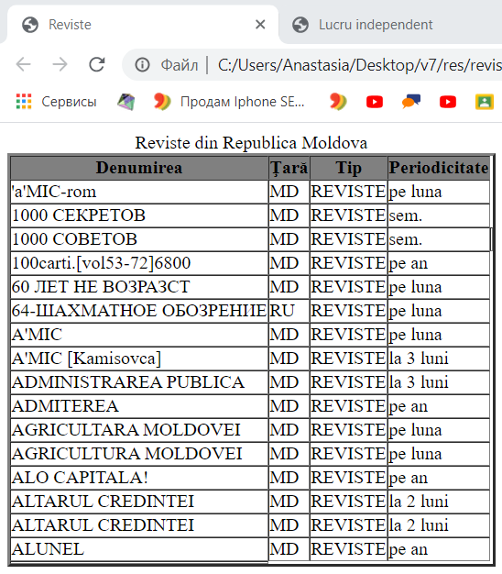

**Codul acestei pagini este:**

**<!DOCTYPE html>**

**<html>**

**<head >**

**<title>Reviste</title>**

**</head >**

**<body>**

**<table border="3" cellpadding="0" cellspacing="0">**

**<caption >Reviste din Republica Moldova**

**</caption>**

**<thead bgcolor="gray"><tr><th>Denumirea</th><th>Ţară</th><th>Tip</th><th>Periodicitate</th> </tr></thead>**

**<tbody>**

**<tr><td><div>'a'MIC-rom<div>**

**<div>**

**</div>**

**</div>**

**</div></td><td>MD</td><td>REVISTE</td><td>pe luna</td> </tr>**

**<tr><td><div>1000 СЕКРЕТОВ<div>**

**<div>**

**</div>**

**</div>**

**</div></td><td>MD</td><td>REVISTE</td><td>sem.</td> </tr>**

**<tr><td><div>1000 СОВЕТОВ<div>**

**<div>**

**</div>**

**</div>**

**</div></td><td>MD</td><td>REVISTE</td><td>sem.</td><td> </td></tr>**

**<tr><td><div>100carti.[vol53-72]6800<div>**

**<div>**

**</div>**

**</div>**

**</div></td><td>MD</td><td>REVISTE</td><td>pe an</td> </tr>**

**<tr><td><div>60 ЛЕТ НЕ ВОЗРАЗСТ<div>**

**<div>**

**</div>**

**</div>**

**</div></td><td>MD</td><td>REVISTE</td><td>pe luna</td> </tr>**

**<tr><td><div>64-ШАХМАТНОЕ ОБОЗРЕНИЕ<div>**

**<div>**

**</div>**

**</div>**

**</div></td><td>RU</td><td>REVISTE</td><td>pe luna</td> </tr>**

**<tr><td><div>A'MIC<div>**

**<div>**

**</div>**

**</div>**

**</div></td><td>MD</td><td>REVISTE</td><td>pe luna</td> </tr>**

**<tr><td><div>A'MIC [Kamisovca]<div>**

**<div>**

**</div>**

**</div>**

**</div></td>**

**<td>MD</td><td>REVISTE</td><td>la 3 luni</td> </tr>**

**<tr><td><div>ADMINISTRAREA PUBLICA<div>**

**<div>**

**</div>**

**</div>**

**</div></td><td>MD</td><td>REVISTE</td><td>la 3 luni</td> </tr>**

**<tr><td><div>ADMITEREA <div>**

**<div>**

**</div>**

**</div>**

**</div></td><td>MD</td><td>REVISTE</td><td>pe an</td> </tr>**

**<tr><td><div>AGRICULTARA MOLDOVEI<div>**

**<div>**

**</div>**

**</div>**

**</div></td><td>MD</td><td>REVISTE</td><td>pe luna</td> </tr>**

**<tr><td><div>AGRICULTURA MOLDOVEI<div>**

**<div>**

**</div>**

**</div>**

**</div></td><td>MD</td><td>REVISTE</td><td>pe luna</td></tr>**

**<tr><td><div>ALO CAPITALA!<div>**

**<div>**

**</div>**

**</div>**

**</div></td><td>MD</td><td>REVISTE</td><td>pe an</td></tr>**

**<tr><td><div>ALTARUL CREDINTEI<div>**

**<div>**

**</div>**

**</div>**

**</div></td><td>MD</td><td>REVISTE</td><td>la 2 luni</td> </tr>**

**<tr><td><div>ALTARUL CREDINTEI<div>**

**<div>**

**</div>**

**</div>**

**</div></td><td>MD</td><td>REVISTE</td><td>la 2 luni</td> </tr>**

**<tr><td><div>ALUNEL<div>**

**<div>**

**</div>**

**</div>**

**</div></td><td>MD</td><td>REVISTE</td><td>pe an</td> </tr>**

**<tr><td>**

**</td></tr></tbody>**

**</table>**

**</body>**

**<html>**

**Accesând saltarul ”canale TV” vedem:**

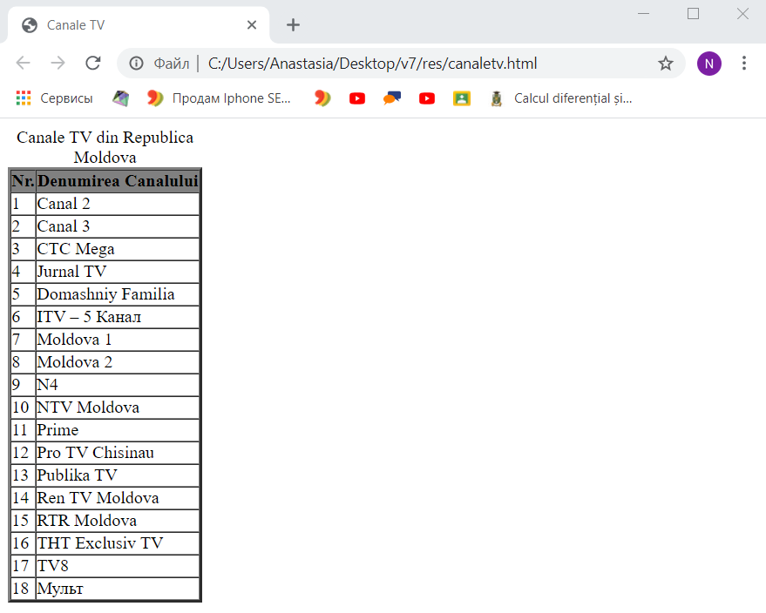

**Codul acestei pagini este:**

**<!DOCTYPE html>**

**<html>**

**<head >**

**<title>Canale TV</title>**

**</head >**

**<body>**

**<table border="3" cellpadding="0" cellspacing="0">**

**<caption >Canale TV din Republica Moldova**

**</caption>**

**<thead bgcolor="gray">**

**<tr>**

**<th>Nr.</th>**

**<th>Denumirea Canalului</th>**

**</tr>**

**</thead>**

**<tbody>**

**<tr>**

**<td>1</td>**

**<td>Canal 2</td>**

**</tr>**

**<tr>**

**<td>2</td>**

**<td>Canal 3</td>**

**</tr>**

**<tr>**

**<td>3</td>**

**<td>CTC Mega</td>**

**</tr>**

**<tr>**

**<td>4</td>**

**<td>Jurnal TV</td>**

**</tr>**

**<tr>**

**<td>5</td>**

**<td>Domashniy Familia</td>**

**</tr>**

**<tr>**

**<td>6</td>**

**<td>ITV – 5 Канал</td>**

**</tr>**

**<tr>**

**<td>7</td>**

**<td>Moldova 1</td>**

**</tr>**

**<tr>**

**<td>8</td>**

**<td>Moldova 2</td>**

**</tr>**

**<tr>**

**<td>9</td>**

**<td>N4</td>**

**</tr>**

**<tr>**

**<td>10</td>**

**<td>NTV Moldova</td>**

**</tr>**

**<tr>**

**<td>11</td>**

**<td>Prime</td>**

**</tr>**

**<tr>**

**<td>12</td>**

**<td>Pro TV Chisinau</td>**

**</tr>**

**<tr>**

**<td>13</td>**

**<td>Publika TV</td>**

**</tr>**

**<tr>**

**<td>14</td>**

**<td>Ren TV Moldova</td>**

**</tr>**

**<tr>**

**<td>15</td>**

**<td>RTR Moldova</td>**

**</tr>**

**<tr>**

**<td>16</td>**

**<td>ТНТ Exclusiv TV</td>**

**</tr>**

**<tr>**

**<td>17</td>**

**<td>ТV8</td>**

**</tr>**

**<tr>**

**<td>18</td>**

**<td>Мульт</td>**

**</tr>**

**</tbody>**

**</table>**

**</body>**

**<html>**

**Laboratorul 1 CSS (Varianta1,R2)**

1. Creaţi o pagină web care va afişa un text aliniat din stînga şi din dreapta.

<html>

<head>

<meta charset="utf-8">

<title>Aliniere</title>

</head>

<body>

<style>

div {

text-align: justify;

}

</style>

<div>Hexagonul regulat este un poligon regulat convex cu șase laturi egale. Unghiurile sale interne sunt congruente, având fiecare măsura de 120° (suma măsurilor unghiurilor acestuia fiind de 720°, ca la orice hexagon). Cercul circumscris unui hexagon regulat are raza egală cu latura hexagonului respectiv. Cercul înscris într-un hexagon regulat are raza egală cu L6√3/2, unde L6 este latura hexagonului respectiv.</div>

</body>

</html>

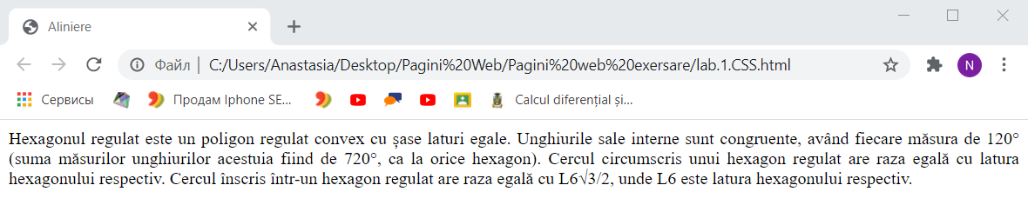

**Laboratorul 2 CSS (VariantaVII)**

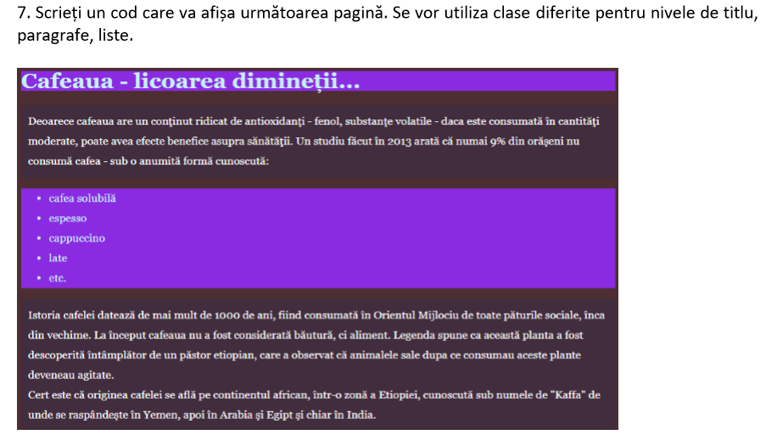

Rezolvare:

<!DOCTYPE html>

<html>

<head>

<style>

body.cl1{background-color: #4c2d32;}

h1.titlu{background-color: #892ae1;

color:white;

margin-top: 0.1%;}

p.par{line-height: 1.7;

background-color: #402c3c;

color:white;

padding-top: 5px;

padding-left: 5px;

padding-bottom: 5px;}

ul.ls{background-color: #892ae1;

line-height: 1.8;

color:white;}

</style>

</head>

<body class="cl1">

<h1 class="titlu">Cafeaua - licoarea dimine&#355;ii...</h1>

<p class="par">Deoareoe cafeaua are un conţinut ridicat de antioxidanţi - fenol, substanţe volatile - daca este consumata in cantitaţi <br>

moderate, poate avea efecte benetice asupra sanătăţii. Un studiu făcut în 2013 arată că numai 9% din oraseni nu <br>

consuma cafea - sub o anumită formă cunoscută:<br></p>

<ul class="ls">

<li>cafea solubila</li>

<li>espresso</li>

<li>cappuccino</li>

<li>late</li>

<li>etc.</li>

</ul>

<p class="par">Istoria cafelei datează de mai mult de 1000 de ani, flind consumata in Orientul Mijlociu de toate paturile sociale, inca <br>

din vechime. La inceput cafeaua nu a fost considerata bautura, ci aliment. Legenda spune ca această planta a fost <br>

deseoperită intamplator de un pastor etiopian, care a observat că animalele sale dupa ce consumau aceste plante <br>

deveneau agitate.<br>

Cert este că originea cafelei se află pe continentul african, intr-o zonă a Etiopiei, cunoscută sub numele de "Kaffa" de <br>

unde se raspândeşte in Yemen, apoi in Arabia şi Egipt si chiar in India.<br></p>

</body>

<html>

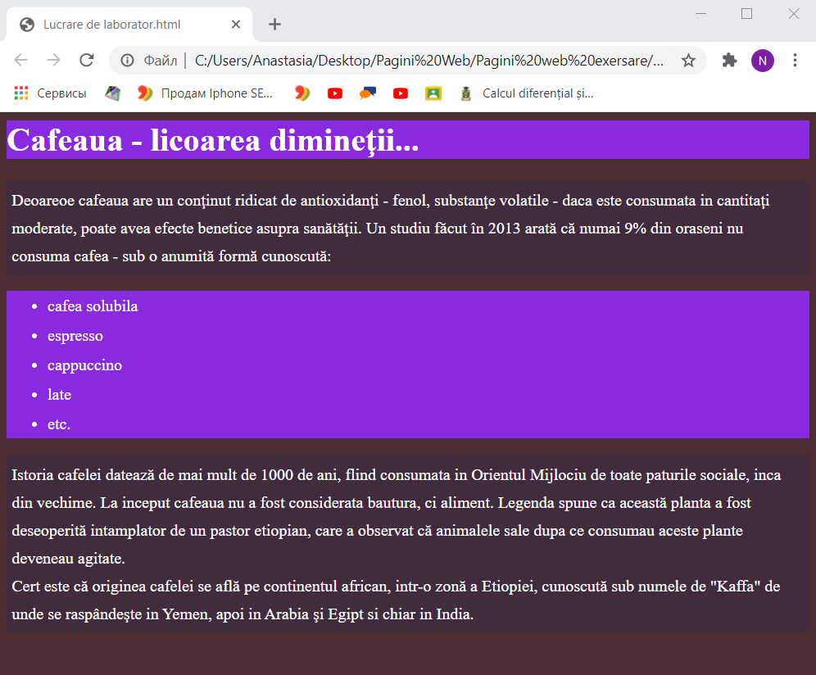

**Laboratorul 3 CSS** (Varianta VIII)

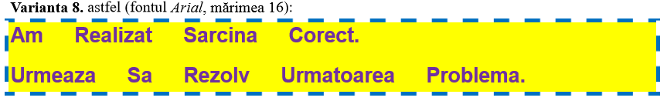

**<!DOCTYPE html>**

**<html>**

**<head>**

**<style>**

**p.labor2{**

**display: block;**

**background-color: yellow;**

**color:#7030a0;**

**outline-style:dashed;**

**outline-color: #0070c0;**

**outline-width: thick ;**

**word-spacing: 1em;**

**font-size:16;**

**font-family: Arial;**

**text-transform: capitalize;**

**font-weight: bold;**

**line-height: 1.8;**

**}**

**</style>**

**</head>**

**<body>**

**<p class="labor2">**

**Am realizat sarcina corect. <br>**

**Urmeaza sa rezolv urmatoarea problema.**

**</p>**

**</body>**

**</html>**

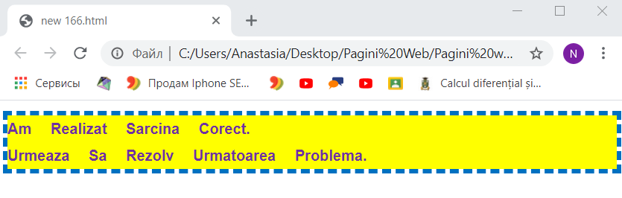

**Laboratorul 4 CSS**

**Biografie:** [**https://drive.google.com/file/d/15ABguNaJfTCk9WYJDiyMG7-MHSyrjBc4/view?usp=sharing**](https://drive.google.com/file/d/15ABguNaJfTCk9WYJDiyMG7-MHSyrjBc4/view?usp=sharing)

**Laboratorul 5 CSS (Varianta 6)**



**<html><head>**

**</head>**

**<body>**

**<svg xmlns="http://www.w3.org/2000/svg" xmlns:xlink="http://www.w3.org/1999/xlink" height="190px">**

**<polygon points="32,12 86,12 111,58 86,105 31,105**

**4,59 " style="stroke: #842a48;fill: #de7e9f;stroke-width: 4;">**

**</polygon>**

**</svg>**

**</body></html>**

